Module 01 Lab 01 Used Car Pricing Screenshot Evidence and Discussion
Reference label for this notebook: Lab1 (each heading below is numbered Lab1_1, Lab1_2 and so on).
This document collects the screenshots I took while completing Module 01 Lab 01, Importing Data Sets for used car pricing, and pairs each one with a heading that follows the notebook from the first section to the last. The lab loads the automobile dataset auto.csv, 205 rows and 26 columns with no header row, adds the column names, replaces the question mark markers and answers the three questions of the notebook. The screenshots are numbered in the order they appear in the notebook and the file name of each image is printed under it, so the headings here can be matched one to one with the submitted files.

Lab1_1. Section 1 Data acquisition and the source of the dataset
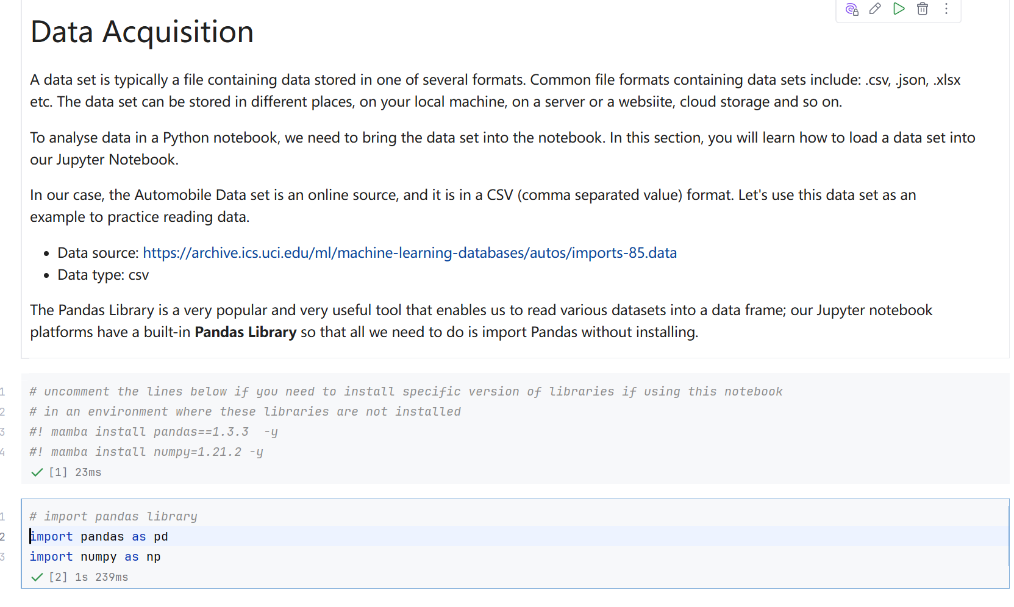
Screenshot file: 01_markdown_Data_Acquisition.png
(image width 16.4 cm, scale to fit)
The lab opens by introducing the automobile dataset and stating that it is published as a CSV file, so pandas can read it directly. This screenshot fixes the starting point of the work.

Lab1_2. Section 1 Downloading auto.csv into the working folder
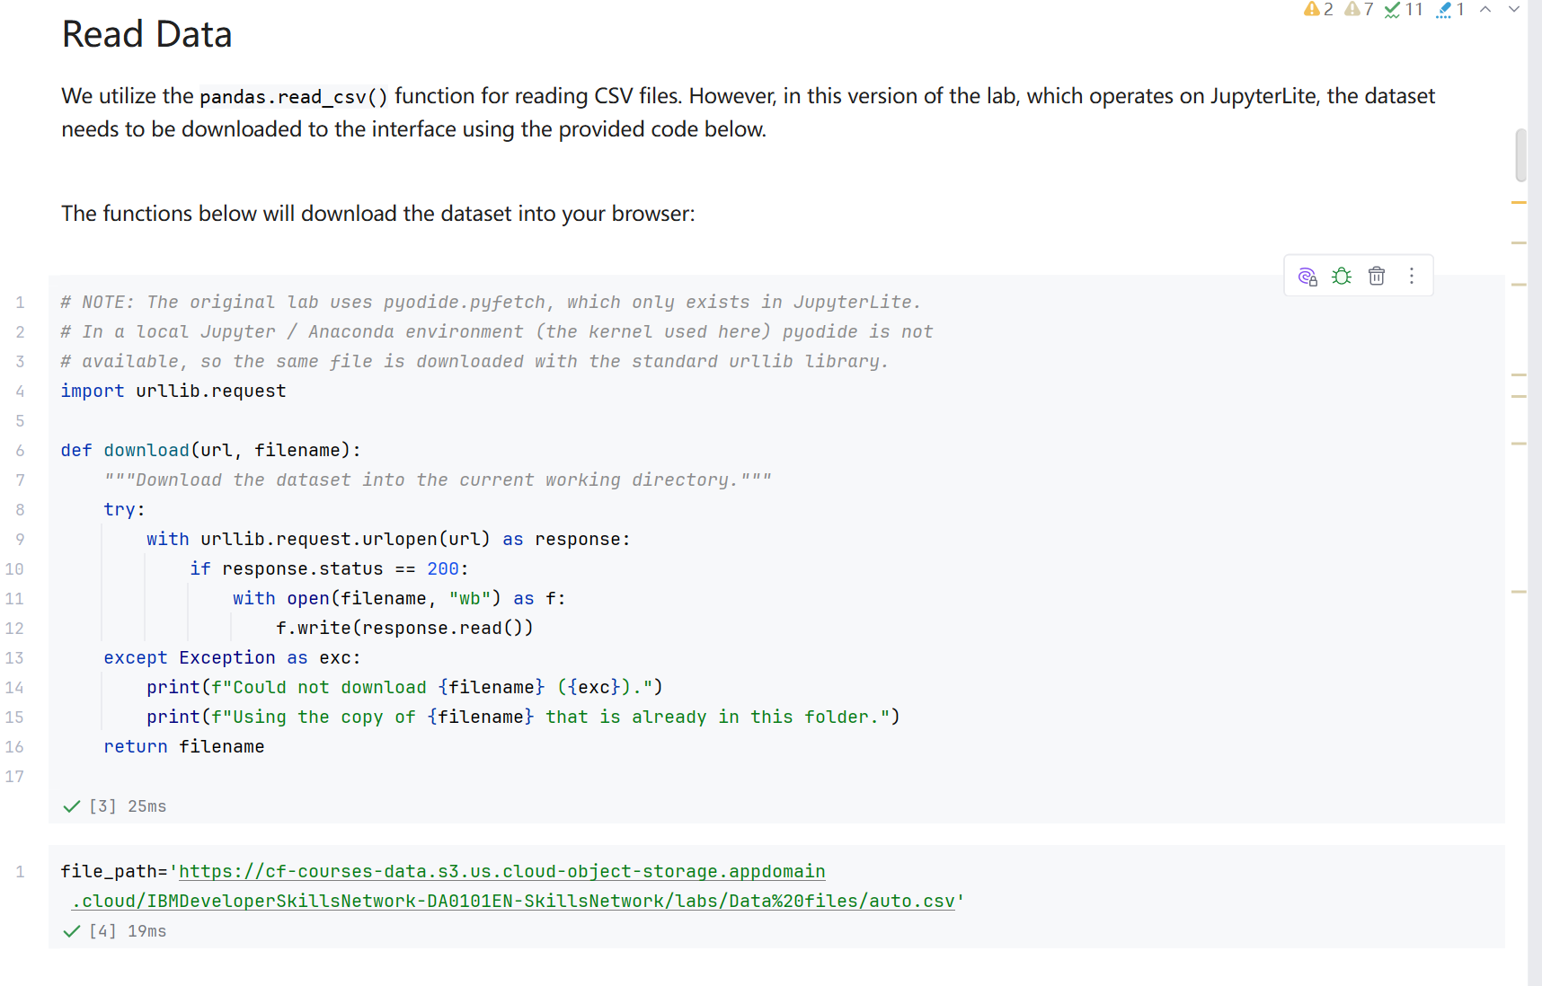
Screenshot file: 02_download_function_urllib.png
(image width 16.4 cm, scale to fit)
The download function fetches the CSV with urllib and writes it to auto.csv in the working directory so the following cells can read it locally; if the download fails it reports the error and keeps the existing copy.

Lab1_3. Section 1 Reading the CSV straight from its URL
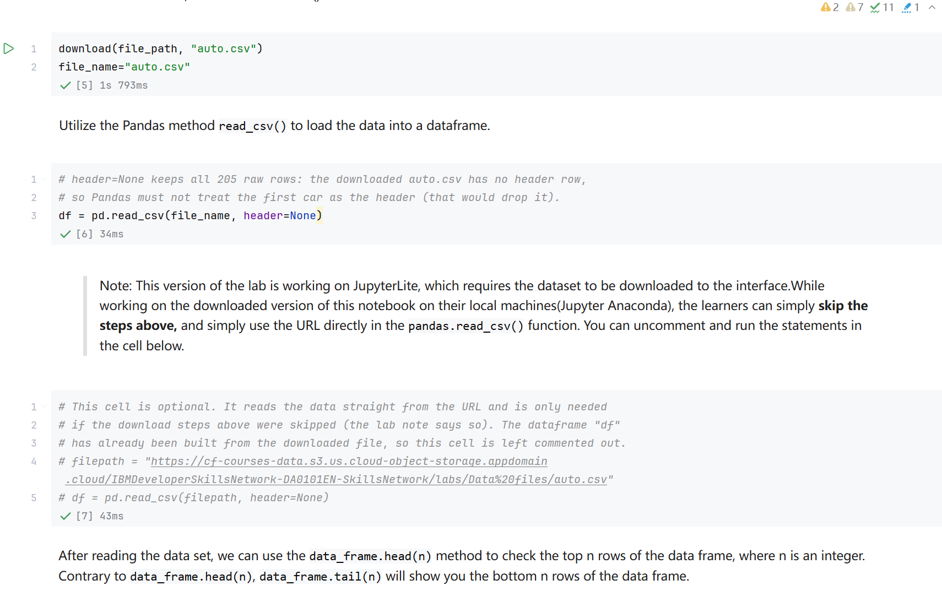
Screenshot file: 03_read_csv_url_option_commented.png
(image width 16.4 cm, scale to fit)
The optional cell shows the shorter route, pandas read_csv applied to the URL itself. It is left commented out because auto.csv is already downloaded, and it records that the raw file has no header row, which is why header=None is used.

Lab1_4. Section 1 First inspection of the raw data with df.head(5)
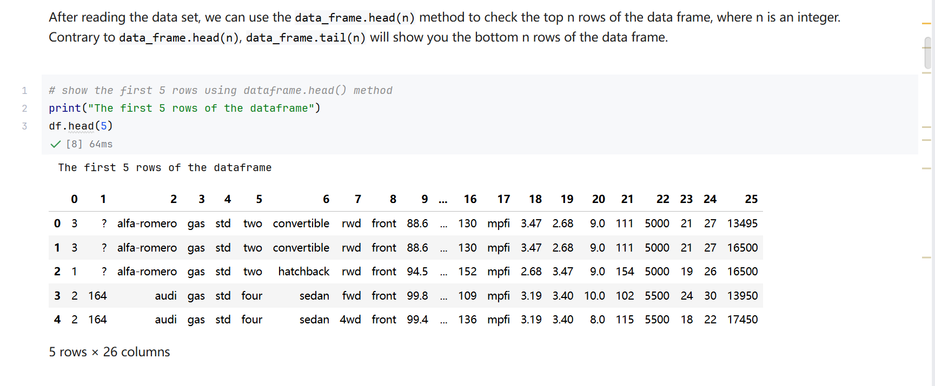
Screenshot file: 04_df.head_5_first_rows.png
(image width 16.4 cm, scale to fit)
The cell prints a caption and then the first five rows. The columns are still numbered from 0 to 25, confirming that pandas found no header and that the column names have to be added manually.

Lab1_5. Question 1 Bottom 10 rows of the dataframe
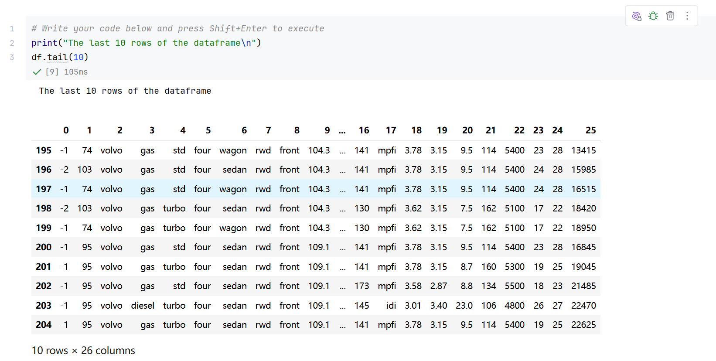
Screenshot file: 05_Q1_df.tail_10.png
(image width 16.4 cm, scale to fit)
df.tail(10) shows the last ten vehicles and verifies the end of the file. The output also shows entries written as a question mark, the marker for missing data that is cleaned in the next section.

Lab1_6. Section 1 Creating the list of 26 column names
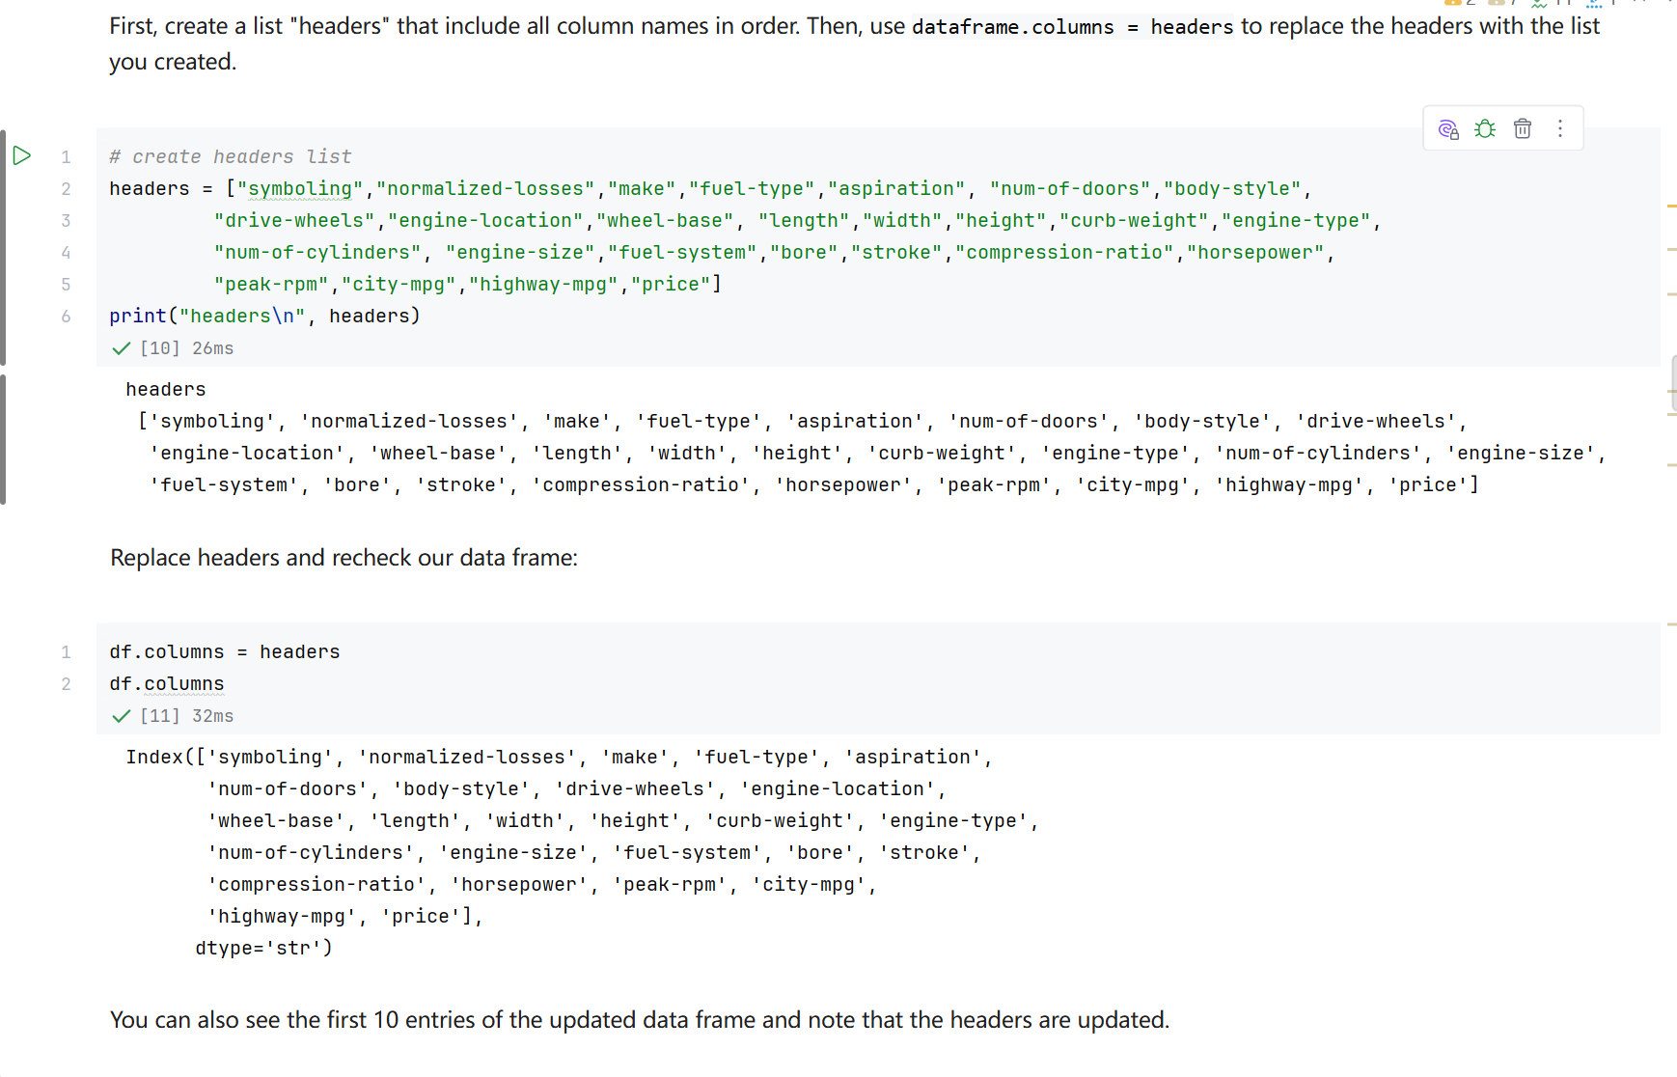
Screenshot file: 06_headers_list_and_df.columns.png
(image width 16.4 cm, scale to fit)
The headers list, covering symboling through price, is built from the documented attribute description and printed. Assigning this list to df.columns gives every column the name it is documented under.

Lab1_7. Section 1 Column names applied and checked with df.head(10)
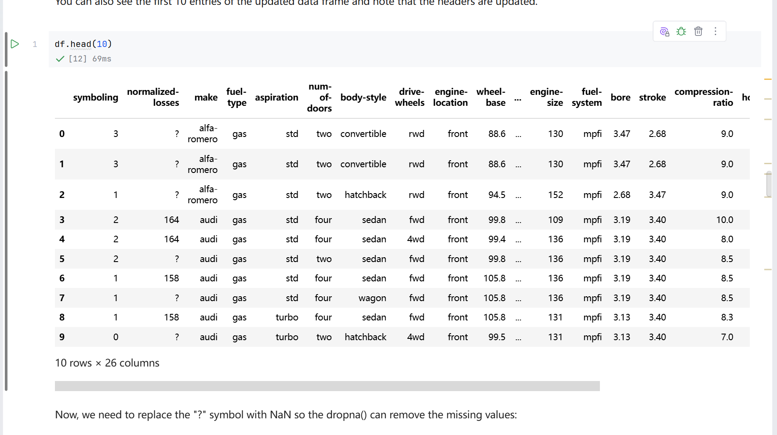
Screenshot file: 07_df.head_10.png
(image width 16.4 cm, scale to fit)
After df.columns = headers, df.head(10) displays the first ten cars with the real attribute names and confirms that the raw columns line up with the documented attributes.

Lab1_8. Section 1 The same ten rows, scrolled to the remaining columns
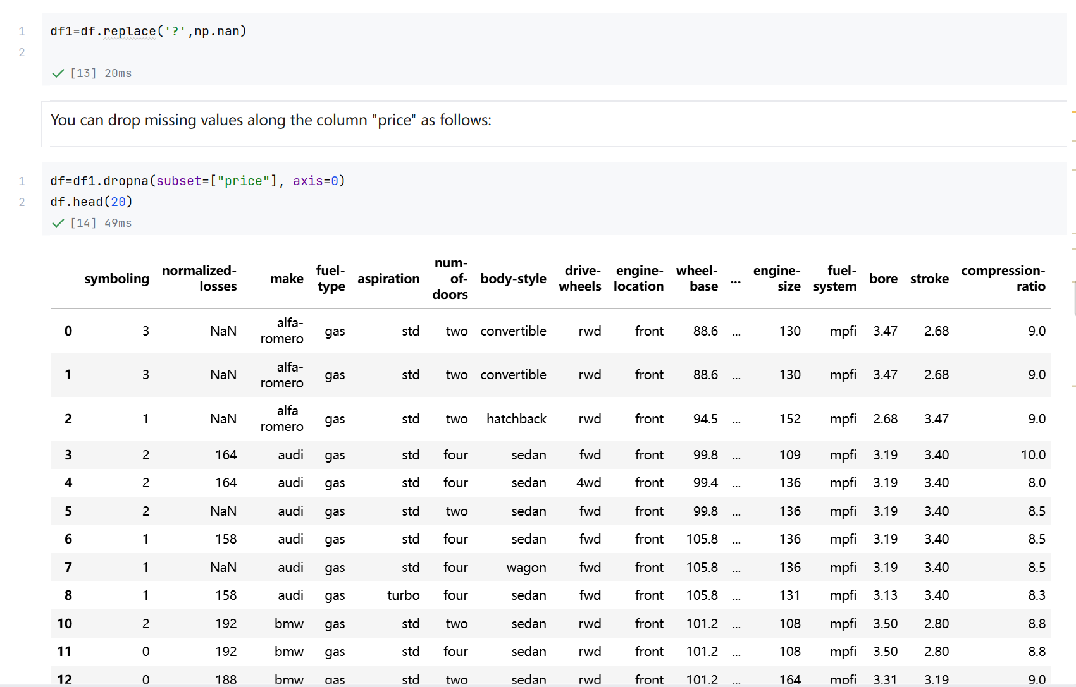
Screenshot file: 08_df.head_20.png
(image width 16.4 cm, scale to fit)
This is the continuation of the same df.head(10) output, showing the right hand columns such as engine size, horsepower, city mpg and price for those ten vehicles.

Lab1_9. Section 1 The same ten rows, scrolled to the foot of the table
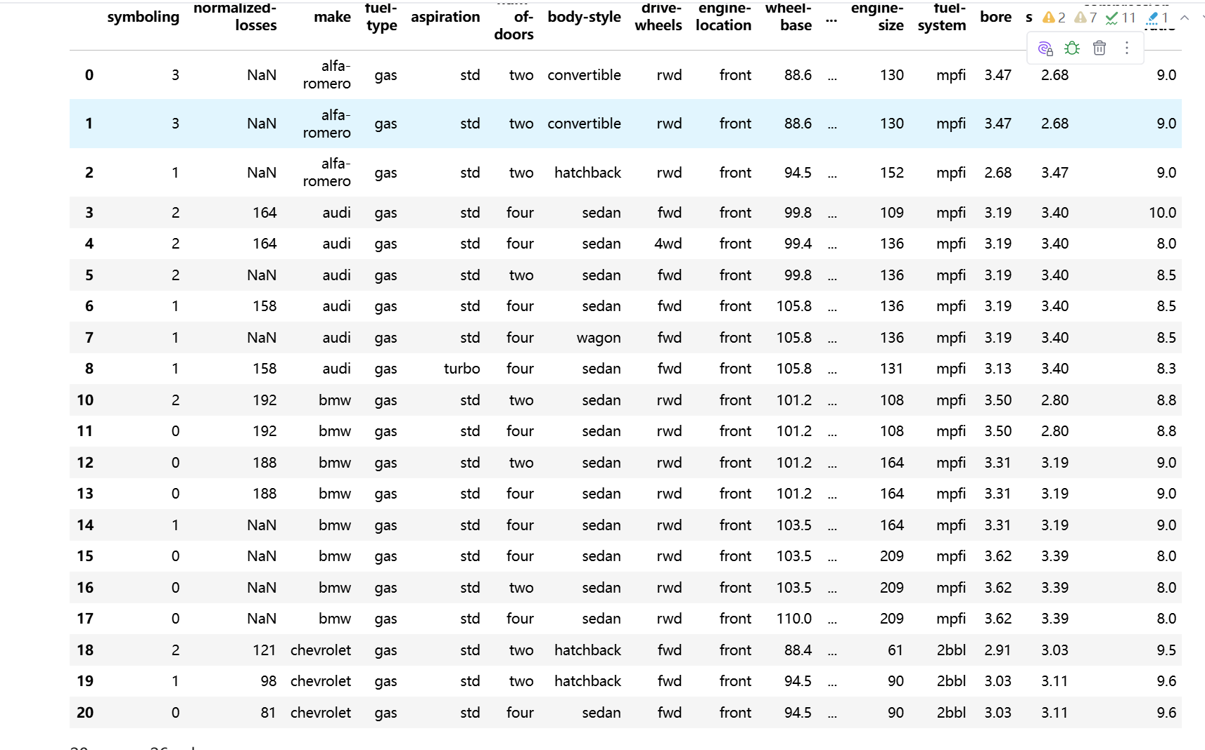
Screenshot file: 09_df.head_20_p2.png
(image width 16.4 cm, scale to fit)
The last part of the same table, included as evidence that all 26 renamed columns render correctly in the notebook.

Lab1_10. Question 2 Column names of the dataframe
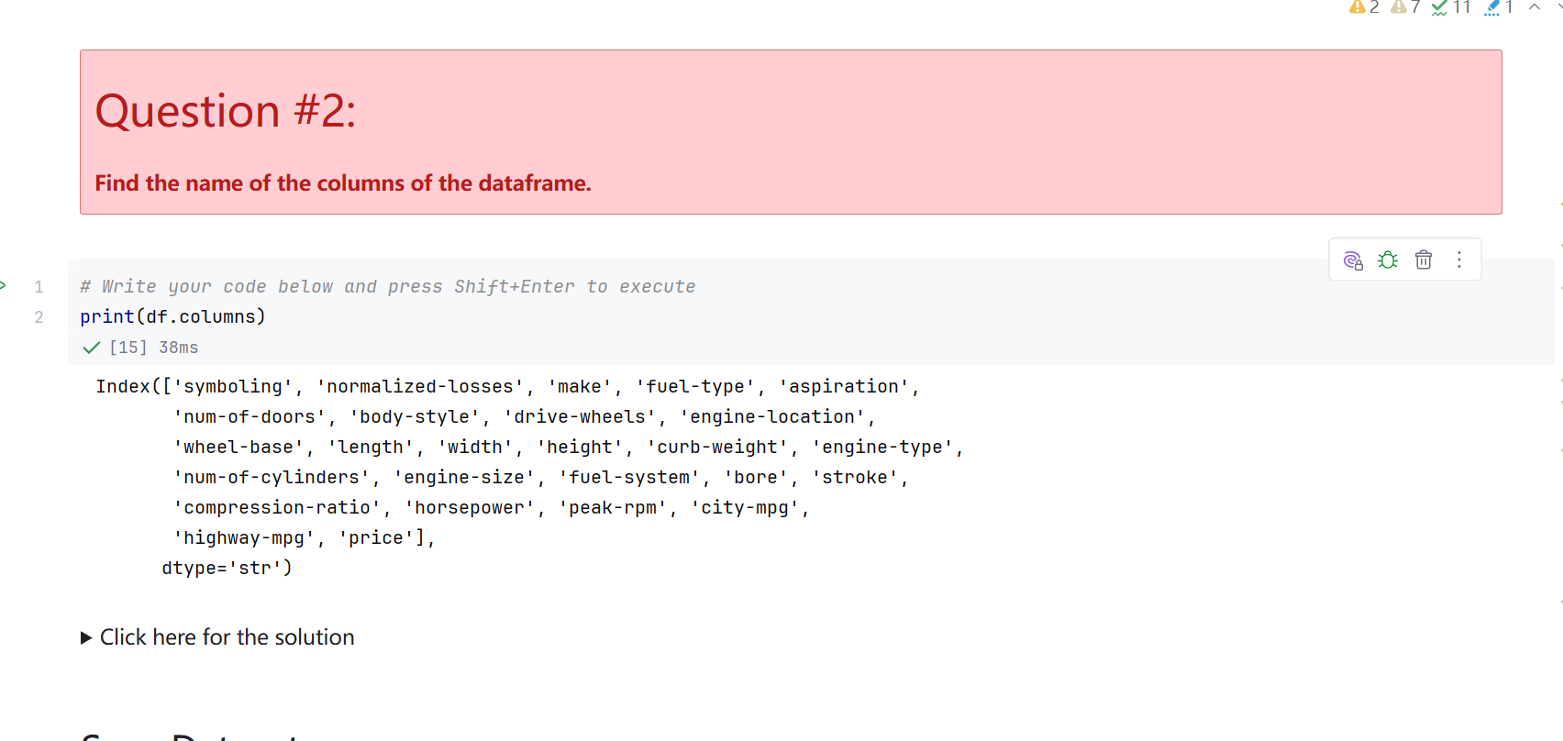
Screenshot file: 10_Q2_df.columns.png
(image width 16.4 cm, scale to fit)
print(df.columns) lists all 26 names in order and confirms that the header list was applied to the frame.

Lab1_11. Section 2 Data types of every column with df.dtypes
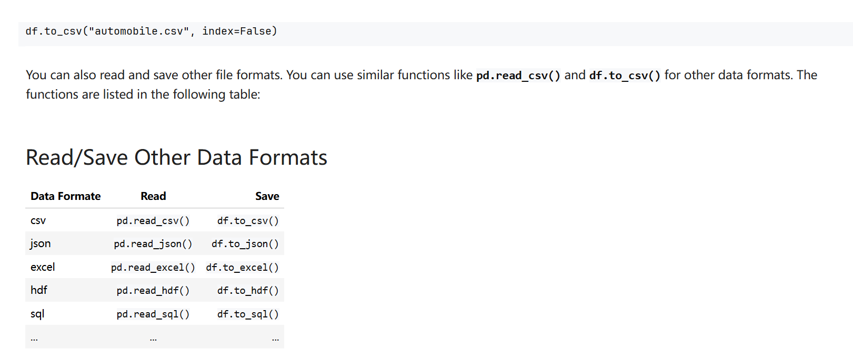
Screenshot file: 11_df.dtypes.png
(image width 16.4 cm, scale to fit)
df.dtypes reports the type of each column: symboling and curb-weight are integers, the physical measurements such as wheel-base are floats, and the remaining attributes are text because they still contain the question mark marker.

Lab1_12. Section 2 The same type list printed out
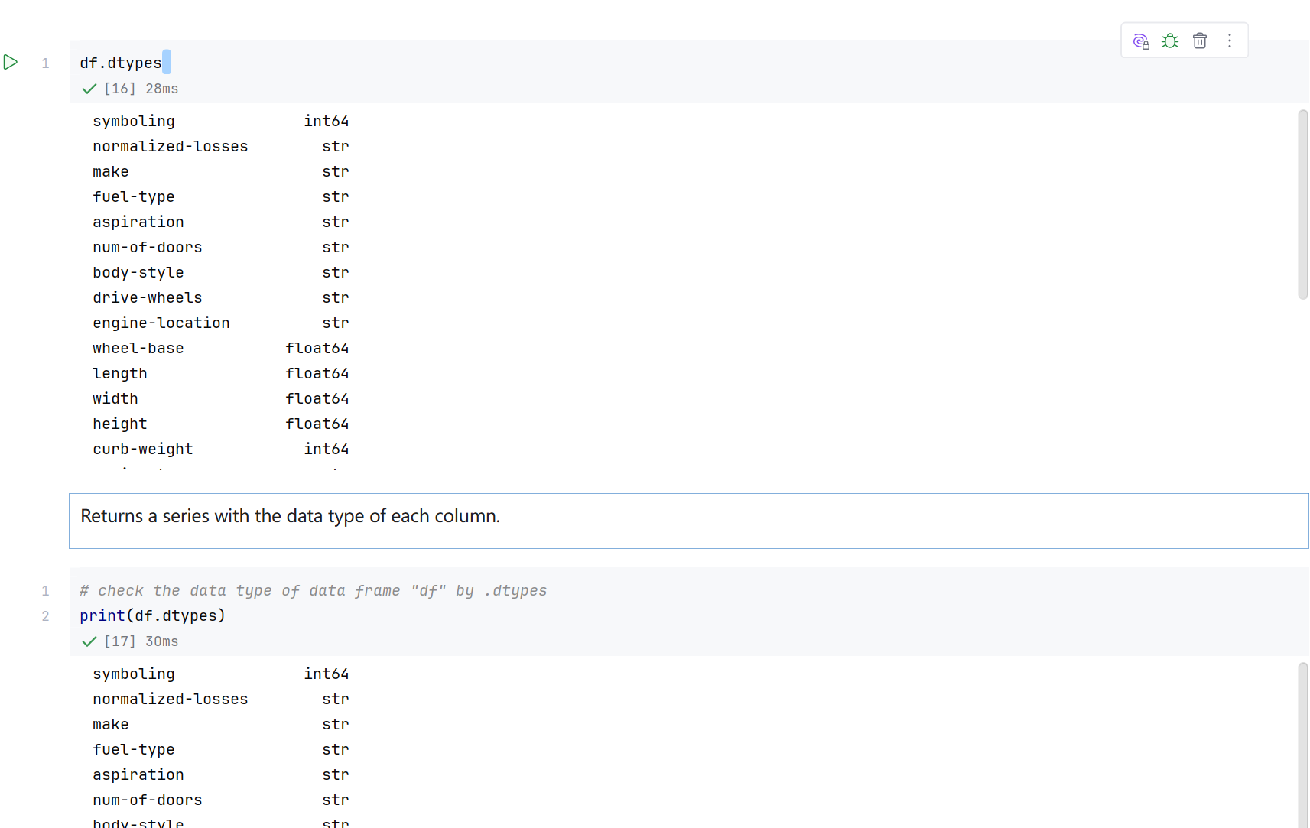
Screenshot file: 12_print_df.dtypes.png
(image width 16.4 cm, scale to fit)
print(df.dtypes) repeats the previous result in plain text, the version kept as the readable record of the column types.

Lab1_13. Section 2 Statistical summary of the numeric columns with df.describe
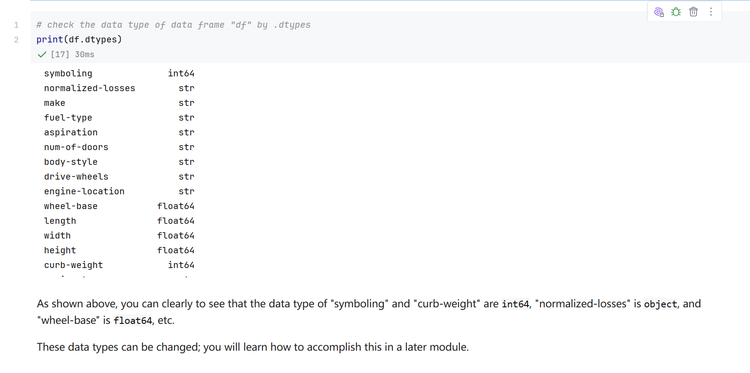
Screenshot file: 13_df.describe.png
(image width 16.4 cm, scale to fit)
df.describe() returns the count, mean, standard deviation, minimum, the three quartiles and the maximum for every numeric attribute. The count of 205 shows that no row has been lost at this stage.

Lab1_14. Section 2 The same summary scrolled to the right hand columns
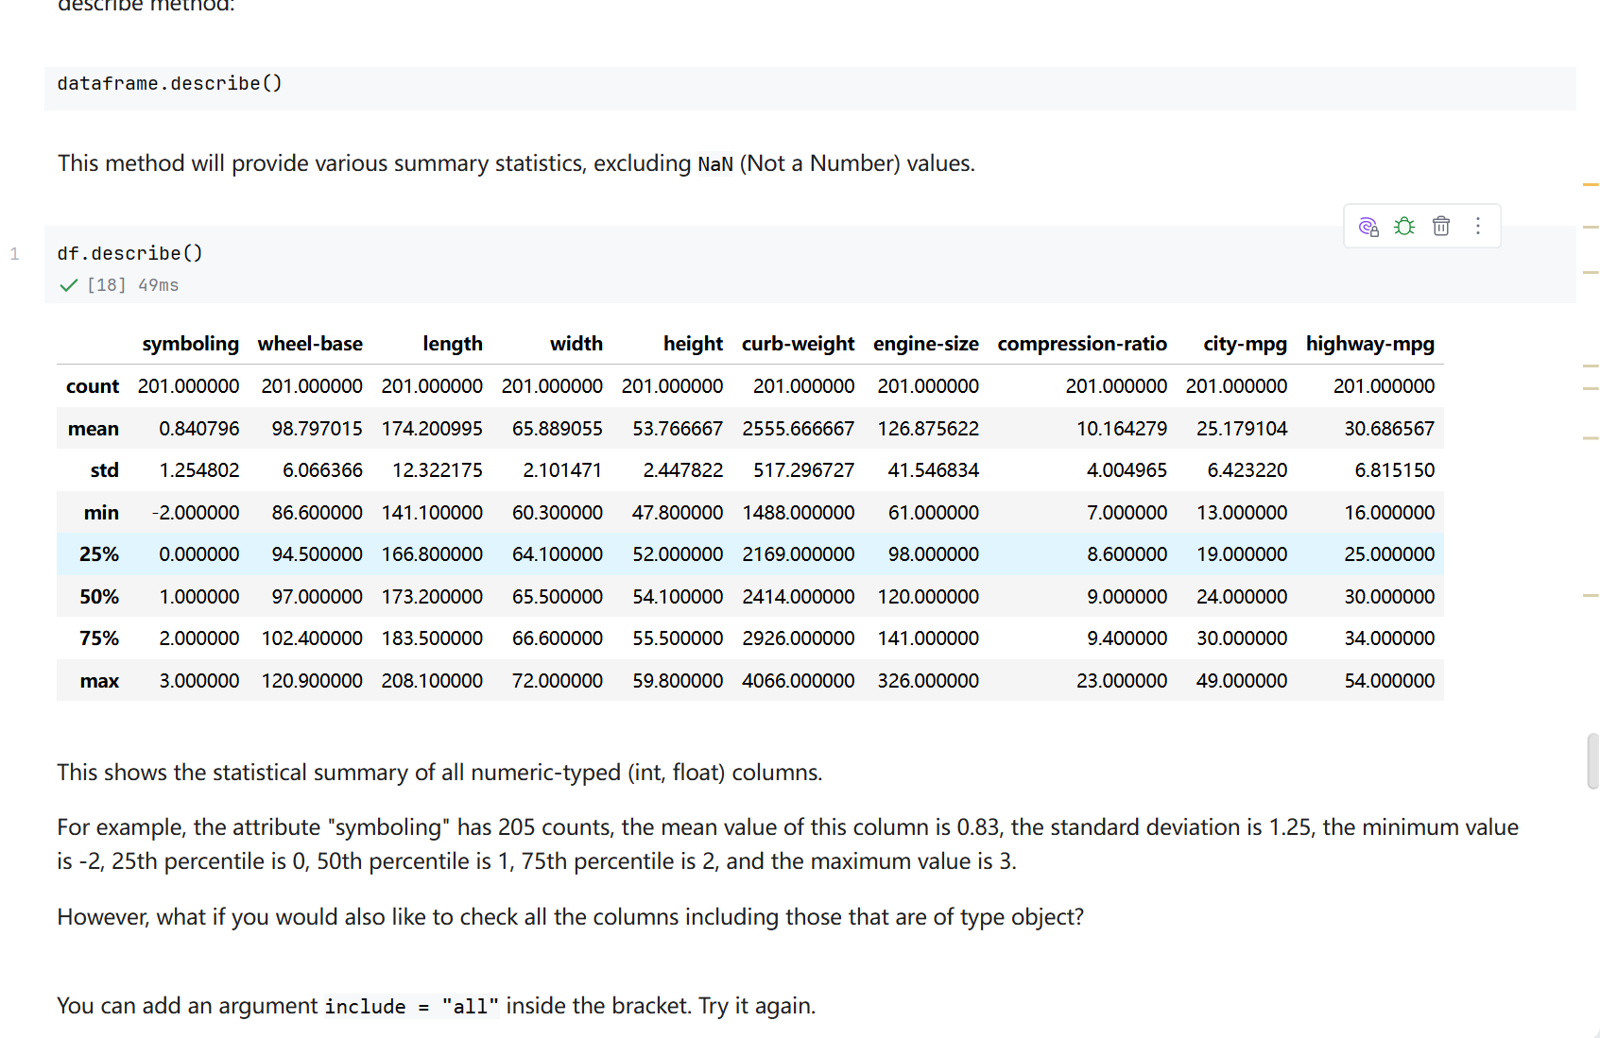
Screenshot file: 14_df.describe_p2.png
(image width 16.4 cm, scale to fit)
The continuation of the describe table, covering the remaining numeric attributes of the dataframe.

Lab1_15. Section 2 Summary that includes the text columns
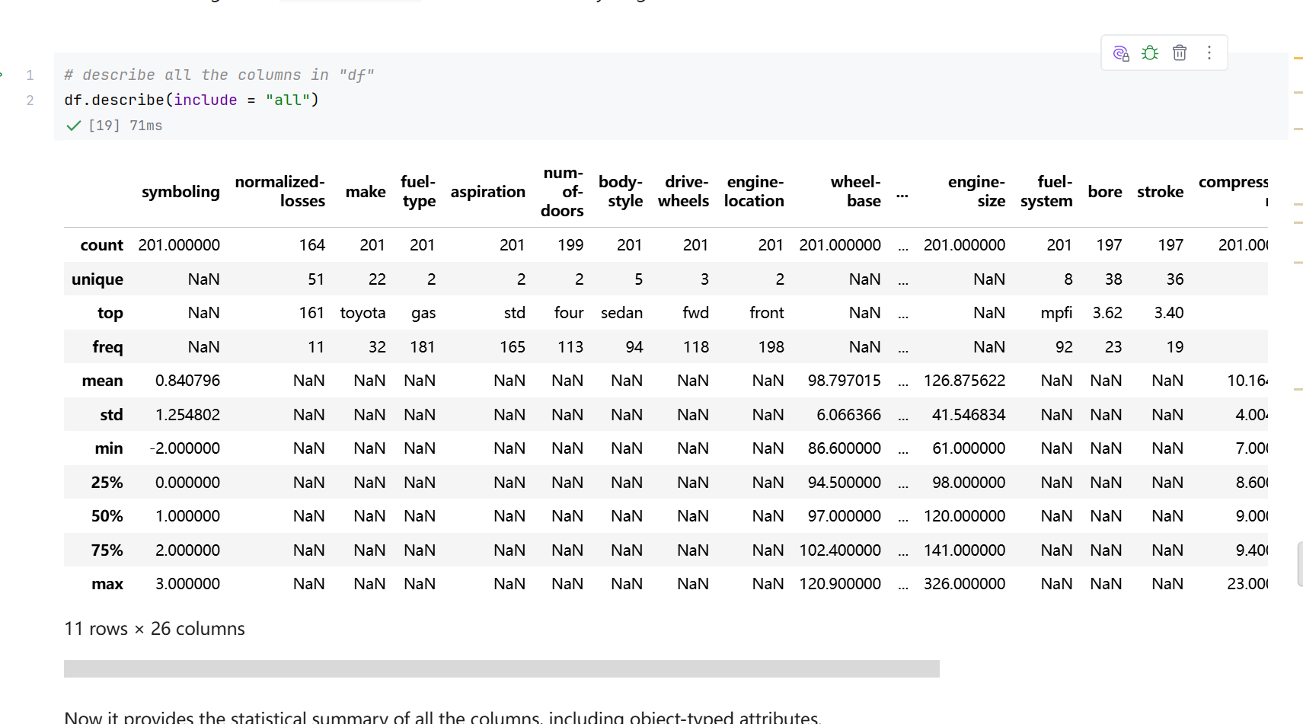
Screenshot file: 15_df.describe_include_all.png
(image width 16.4 cm, scale to fit)
Adding include for object columns extends the table with the frequency statistics, so the number of unique values, the most frequent value and its count appear for make, body style, drive wheels and the other categorical attributes.

Lab1_16. Question 3 Statistics of the length and compression-ratio columns
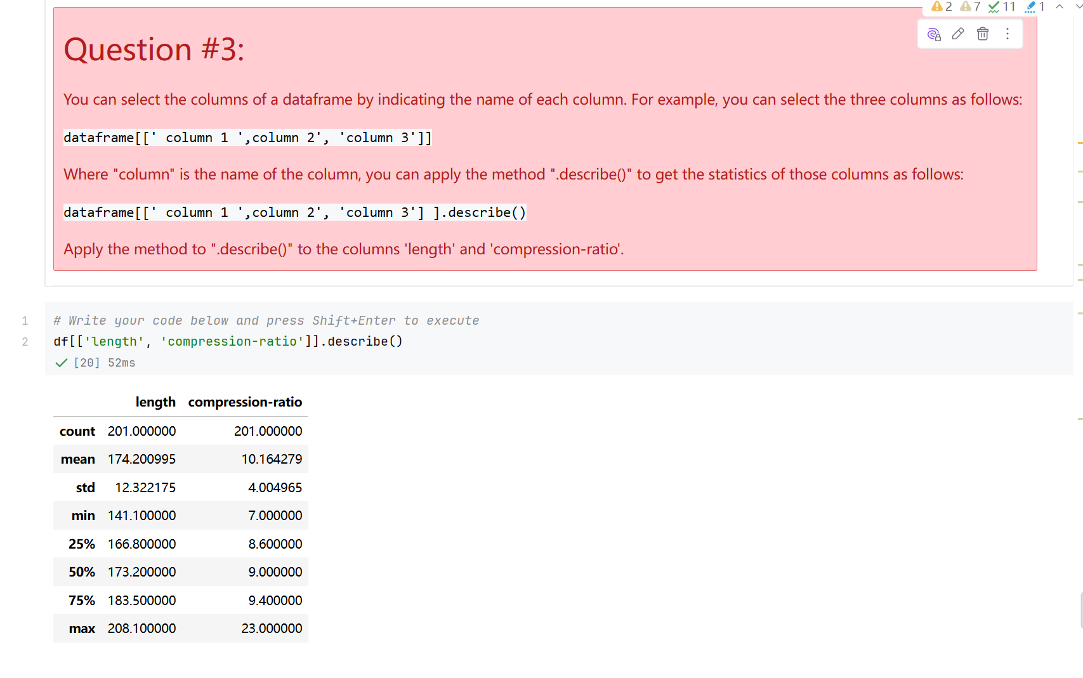
Screenshot file: 16_Q3_df.length_and_compression-ratio.describe.png
(image width 16.4 cm, scale to fit)
df[['length','compression-ratio']].describe() restricts the summary to the two requested columns and shows their central values and spread.

Lab1_17. Section 2 Structure of the dataframe with df.info()
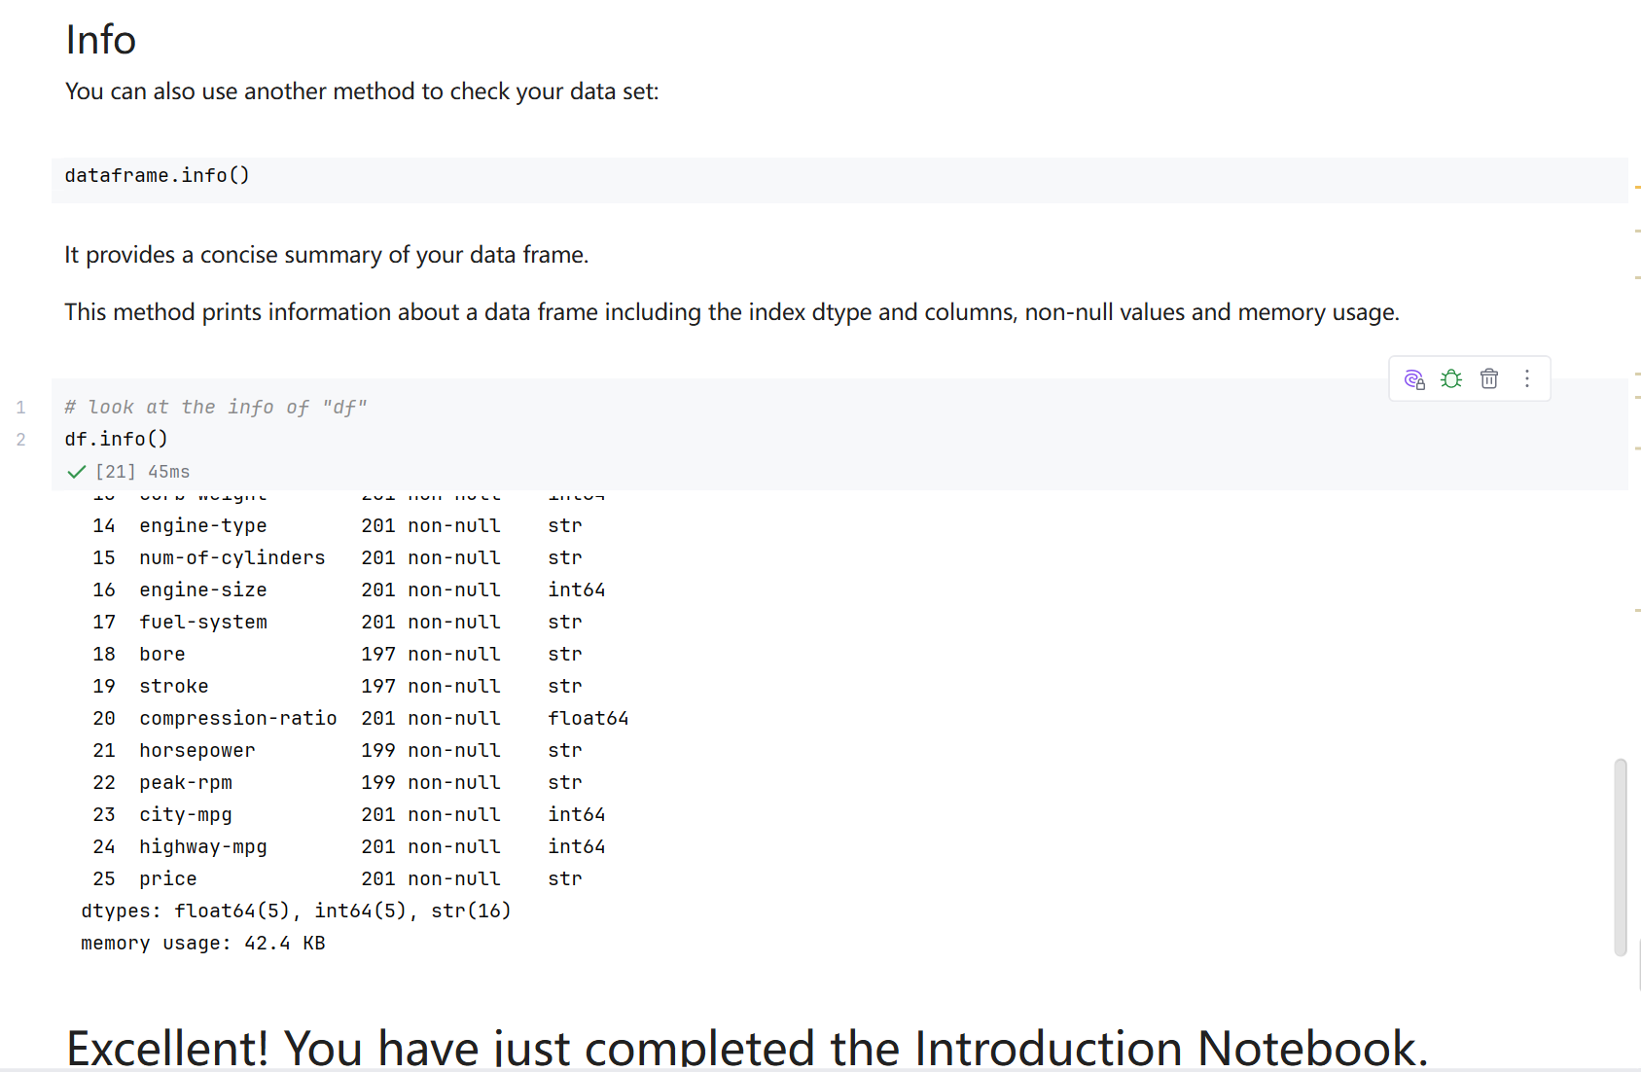
Screenshot file: 17_df.info.png
(image width 16.4 cm, scale to fit)
df.info() summarises the index, the 26 columns, the number of non null values and the memory usage. It reports 201 non null price values, the four cars without a price that are removed when the dataframe is cleaned.

